GreenSite Website. Main (Home) Page.

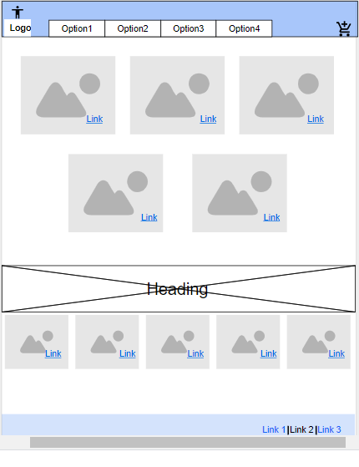

On the home page there are displayed maps of 5 Islands of Hawaii. Once user click on one of them – it will take him to the activities page where user can get information about all available activities on that selected Island.

On the bottom of the main page it will be a carousel of top activities (best rated Luau, helicopter tour, surfing lesson etc).

Activities page

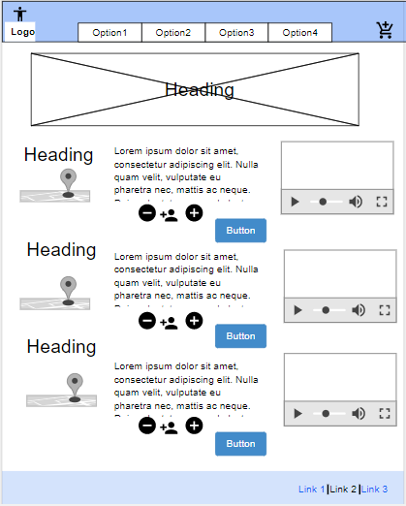

On the Activities Page user can get information about activities (some text and video). Also, it will include a google map with direction how to get to a specific vendor. He will have an option to add to the “cart” any of the activities he would like to do.

Once the user press “Add” Button he will be prompt to the “Details” page where he will be asked to choose Date and Time for the activity. Also all needed requirements – age, weight, names of all participates.

Details Page

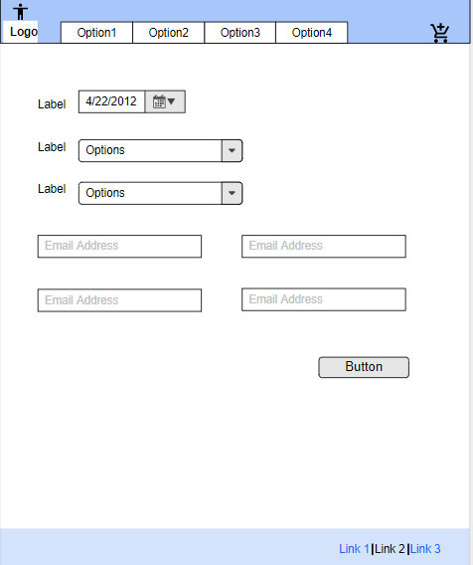

Once the user fill out all required information about chosen activity he can “Checkout”.

Checkout Page

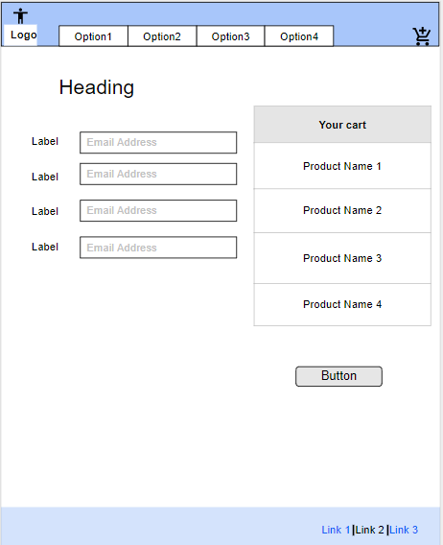

Review users choices and fill out checkout form (User Name/Billing address/Credit Card information). Submit to approve the transaction.